SignExtender Block:
This block will take in datain sample of 32 bits and split it into 2 16bits before performing a sign extension of 8 bits base on the MSB (rightmost bit of each half). The final outputs will be sign_out_L and sign_out_R each of which s 24 bits

Block diagram of SignExtender: shows datain[31:0] as input and sign_out_L/R [23:0]

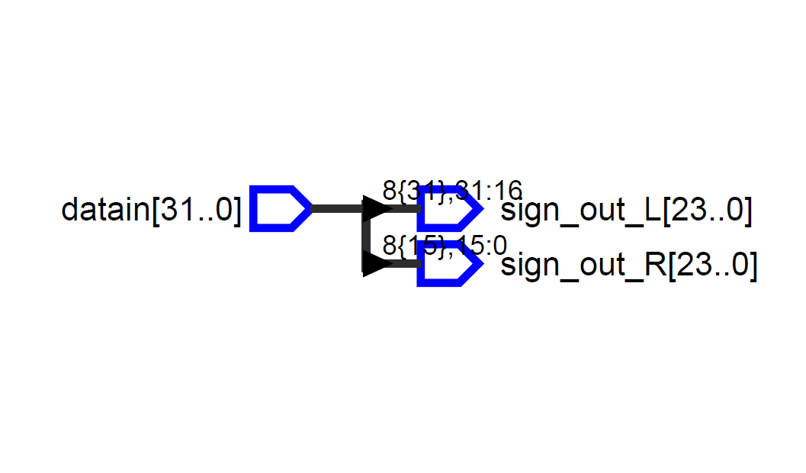
TestBench output of the SignExtender Block it splits datain two L and R

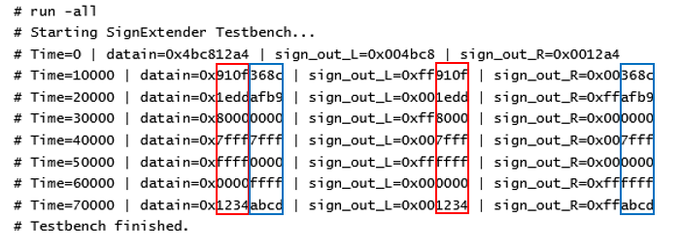

Adder block
This is two block adder meaning it add/substract on both the right and Left side independently. The Block will take input from the SignExtender and from the 1-bitShiftRegister. It will use the MSB of the Coefficient at that stage of the filter to determine whether to perform addition or subtraction. The Block also has two independent outputs adder_outL/R

WaveView: showing sample for both addition and subtraction
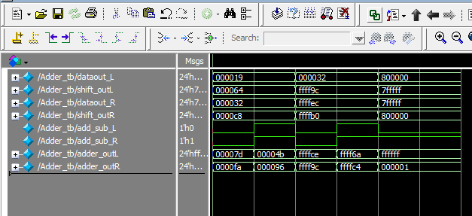

Block Diagram of Adder: shows there are two blocks inside the Adder one for the right computation and one for the Left computation
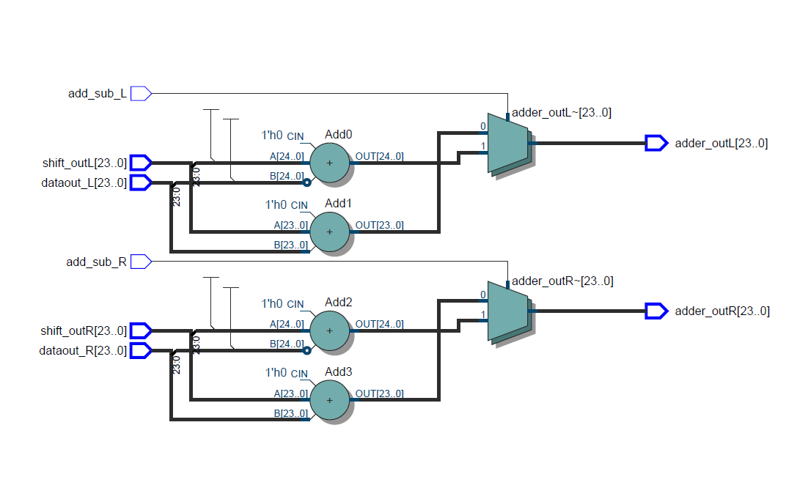
Testbench table: showing values in decimal for easy recognition
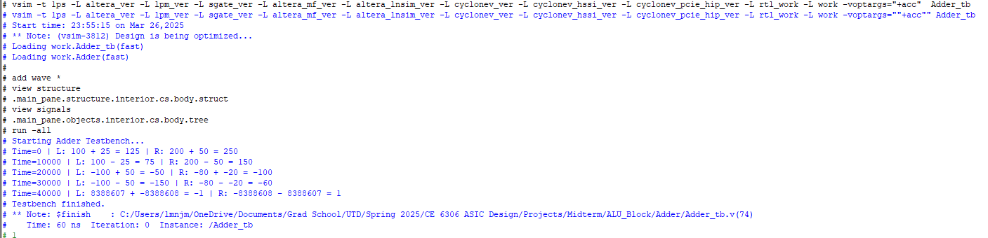

ShiftRightRegister
This is a 1 bit shifter, it takes the output of each side of the adder and shifts it by 1-bit. And sends the results back to the adder where the result will be accumulated with the new datain sample. This process repeats until the convolution is completed, then the final result is sent to the PISO block.

Block Diagram of ShiftRightRegister:

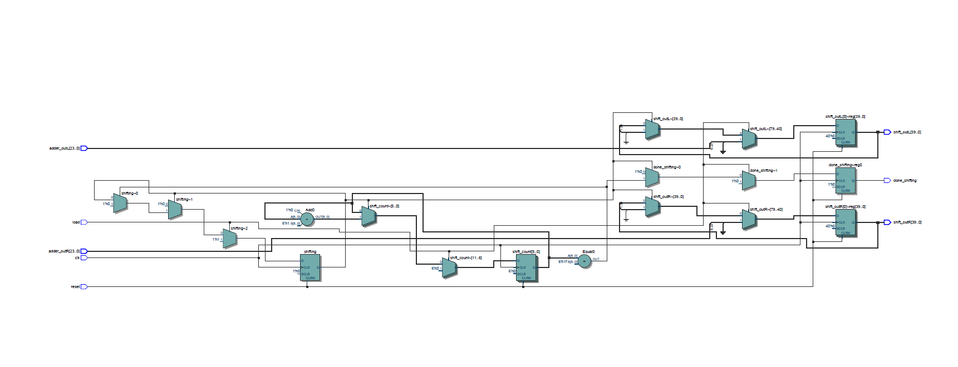
WaveView of the Simulated Testbench
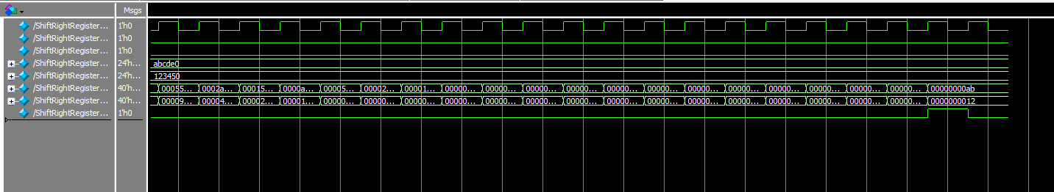
Table showing the simulated result
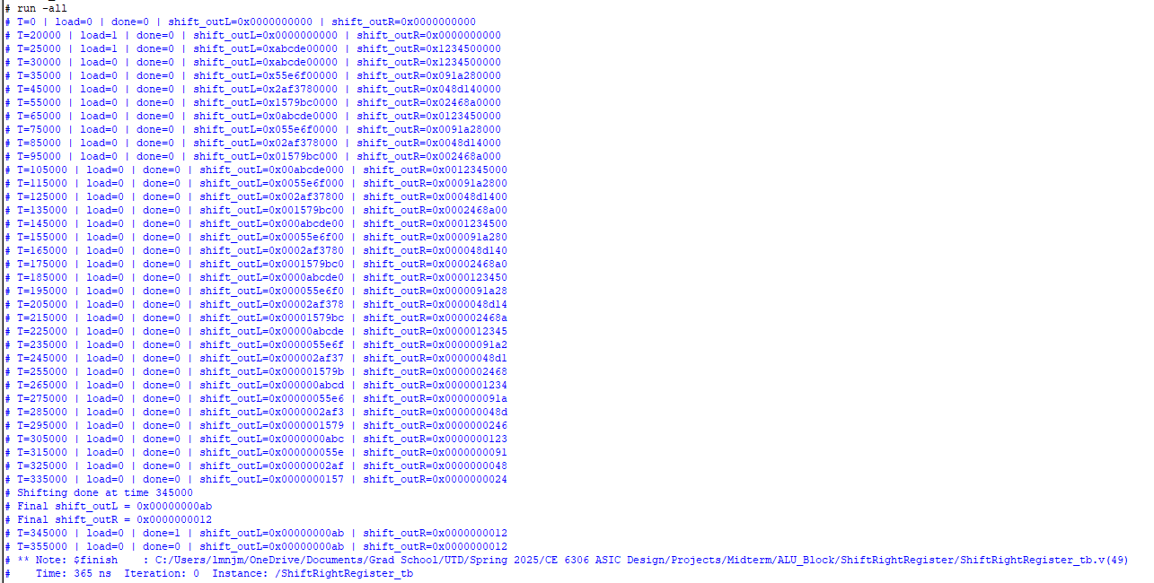

ALU_Controller Block
This controls the interaction between the ALU and other Blocks inside the MSDAP. It also controls the local behavior of the ALU block meaning how the internal blocks inside the ALU interact with each other in terms of shifting and computation. The main challenge in making this block is figuring out when to bring in datain sample or which address of the data_memory to use. An index was created to compute the address of the data_memory to be used at each stage of the convolution. This block is the most challenging part of the ALU block.

WaveView after the Simulation
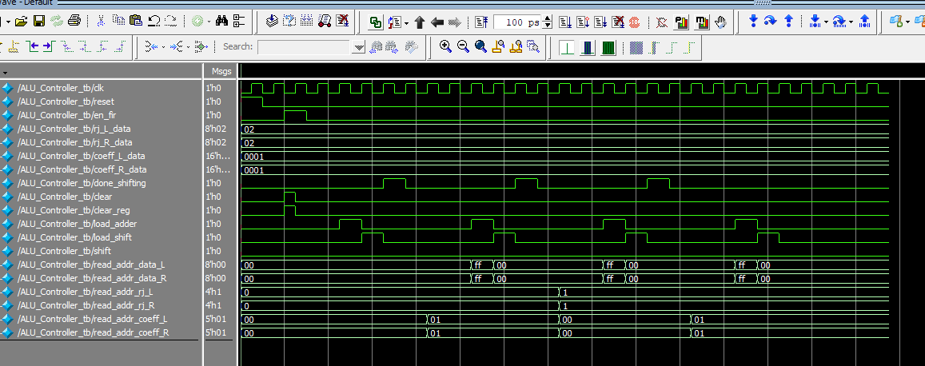
State Diagram of the ALU Finite State Machine
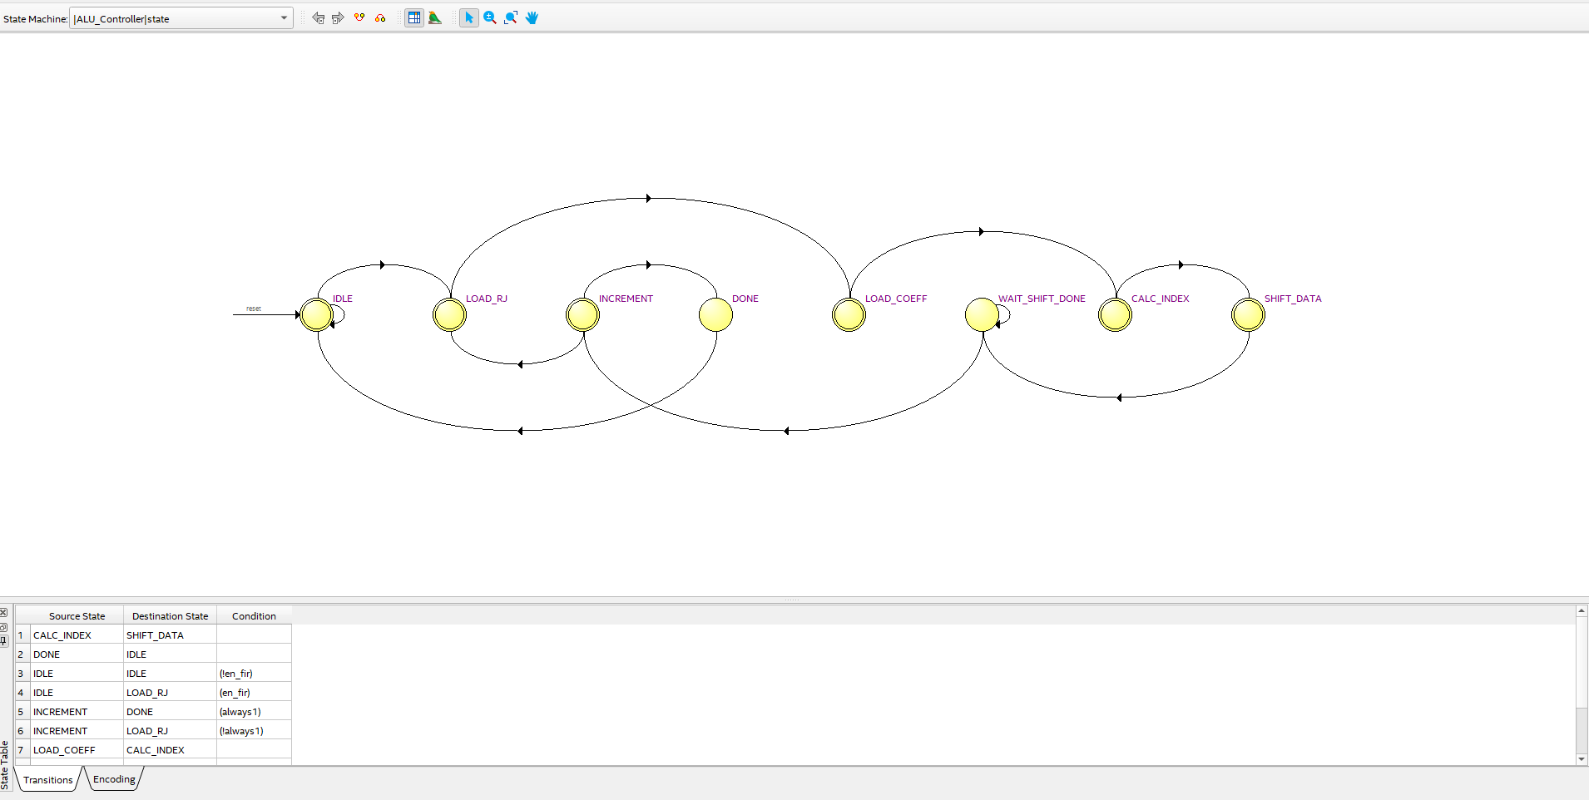
ALU Block diagram: the yellow is the FSM block of the ALU controller
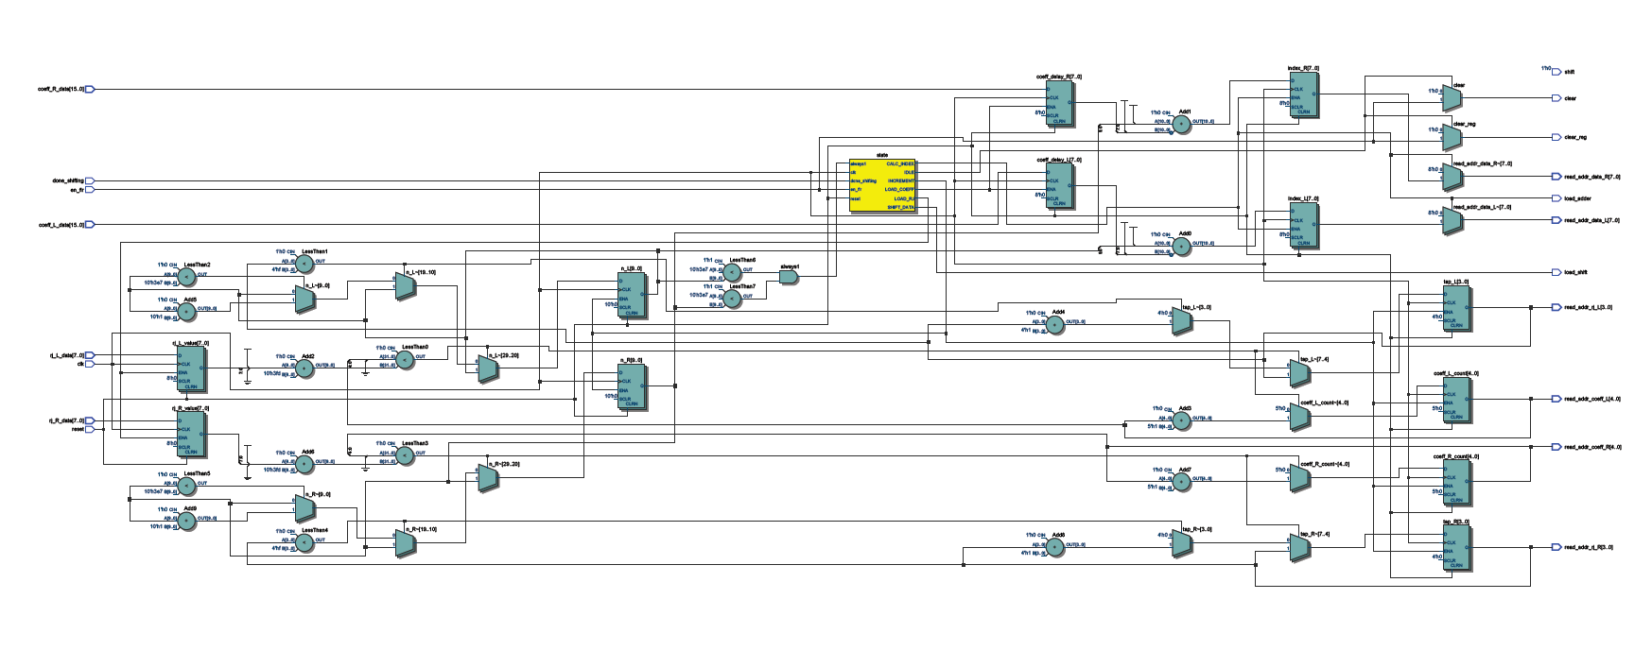
ALU_Top Module
This Block connects all the submodules inside the ALU. Each submodule is connected using the ports name instead of the port order to avoid mismatch of port connections.

WaveView of the ALU_Top Module
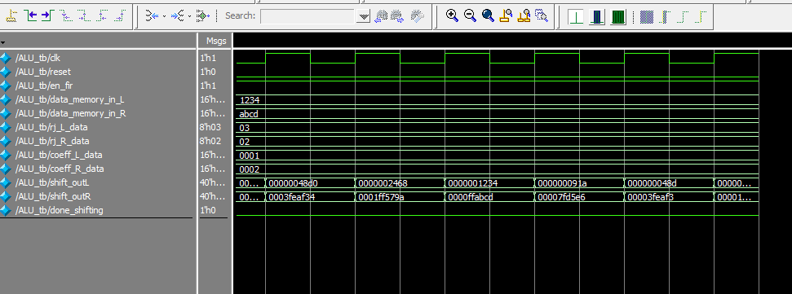
Block Diagram of the ALU Top Module
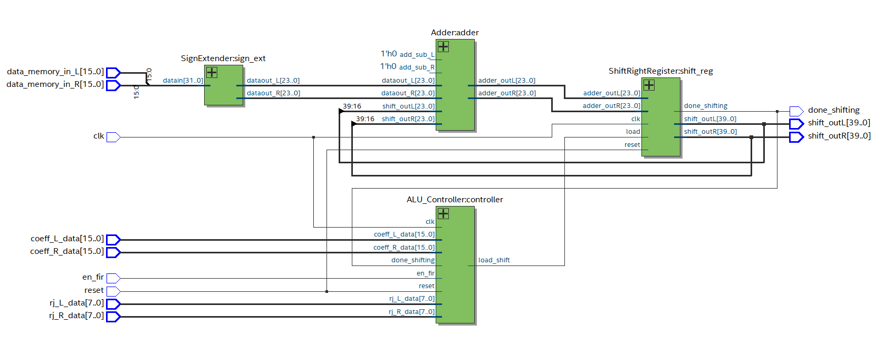
Simulated Output for the ALU_Top
